Lecture Note – ETL Using Tableau Prep
HAEntity Table
- import HAEntity.xlsx
  - check the option Wildcard Union
  - keep the data fields HAEntityId, ParentId, HAEntityType, City, State, Zip, ProfitStatus, Type, YearOpened, OwnershipStatus, VendorSelStrategy, NofStaffedBeds, FTETotal
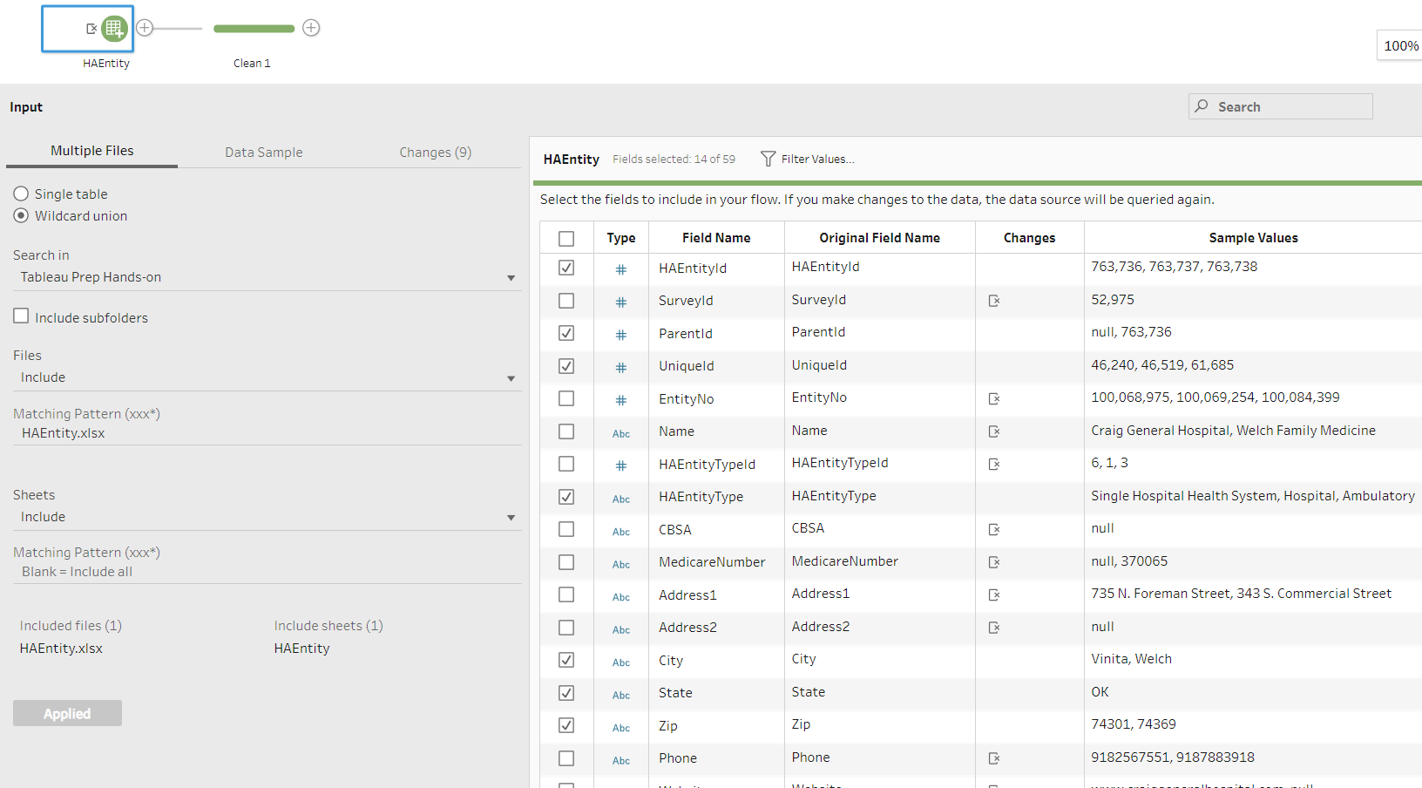
[Note: here when we import data, we can change the data type as well by clicking on the Type icons; Tableau data type include: 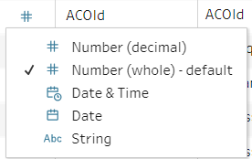]
- Examining and Cleaning HAEntity Data
  - Add a Clean Step
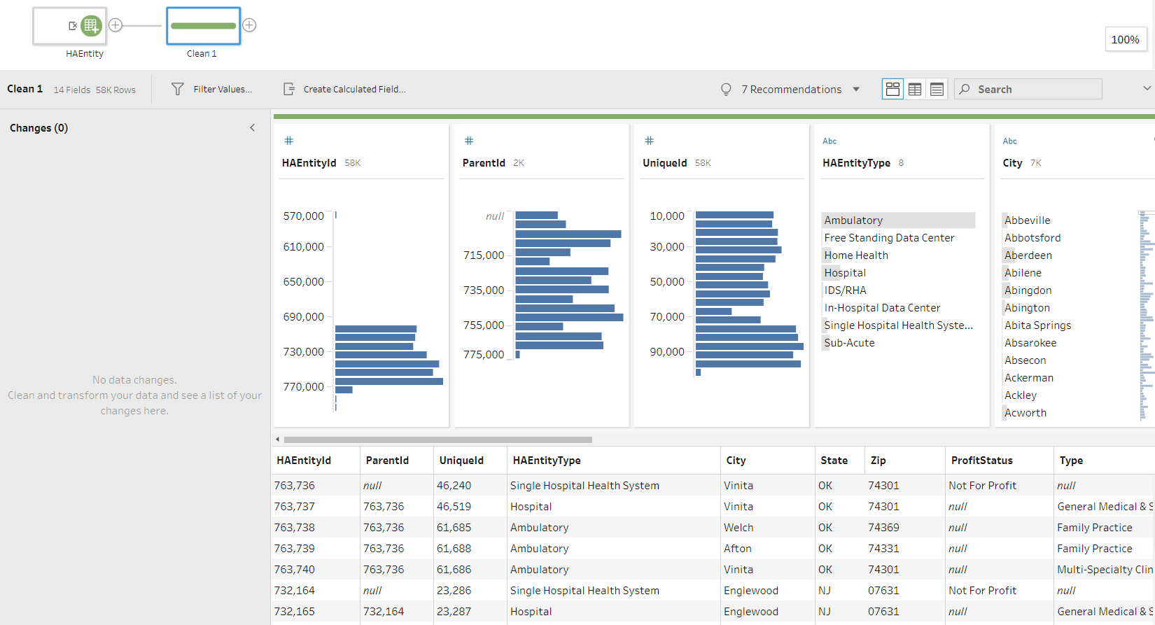
  - This study focuses on US hospitals. So, we filter the data to only include hospitals. Then, we can remove the column HAEntityType, as all rows are hospitals.
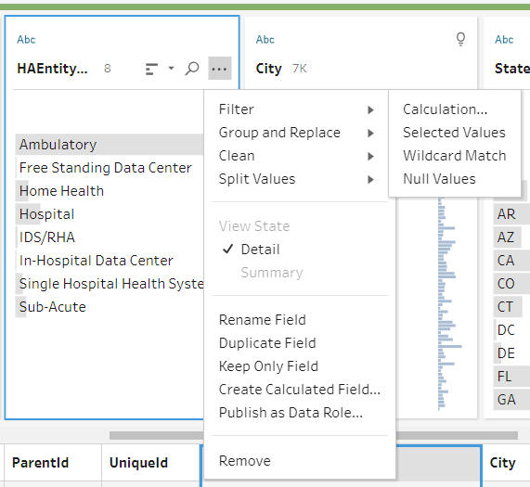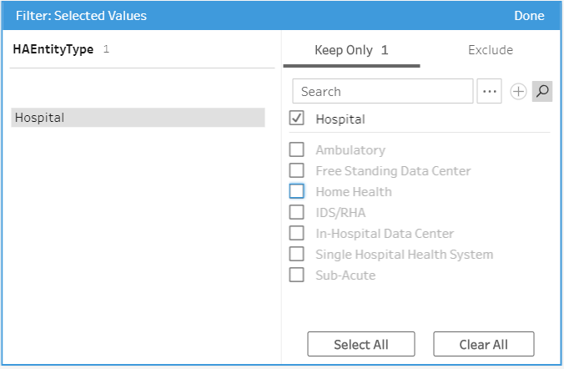
  - We continue to examine the data. For the State field, we notice that there are 2 rows have missing values. Just 2, less than 1% of observations, so we can just delete it. How do you remove it using the filter function?
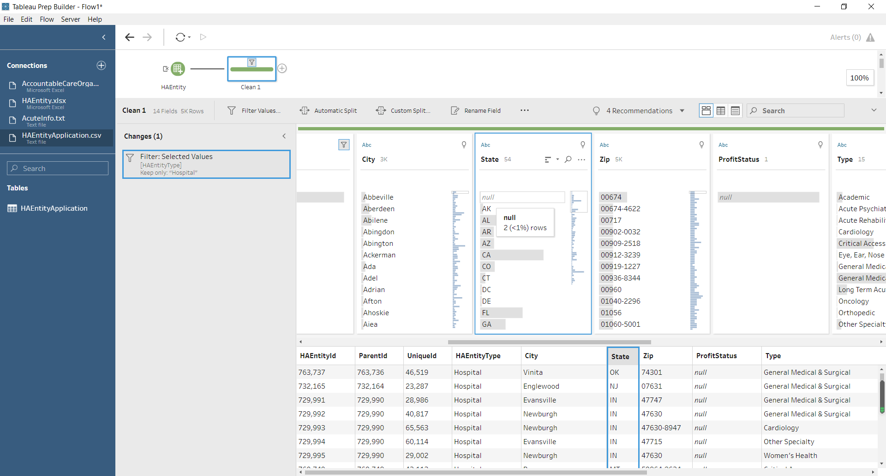
  - Continuing the data examination, we notice that all values in the ProfitStatus field is null. So, we should delete this column.
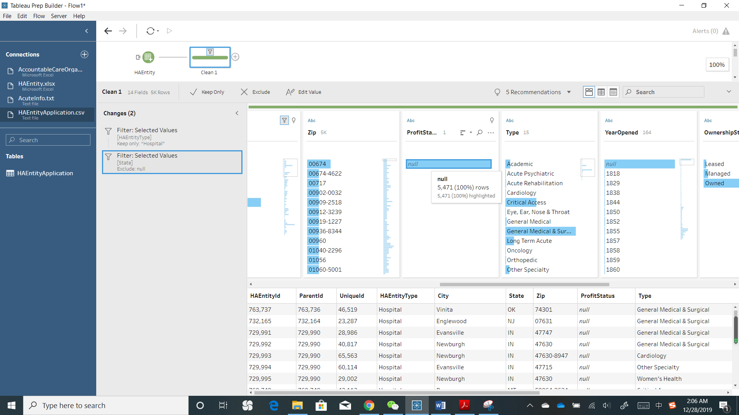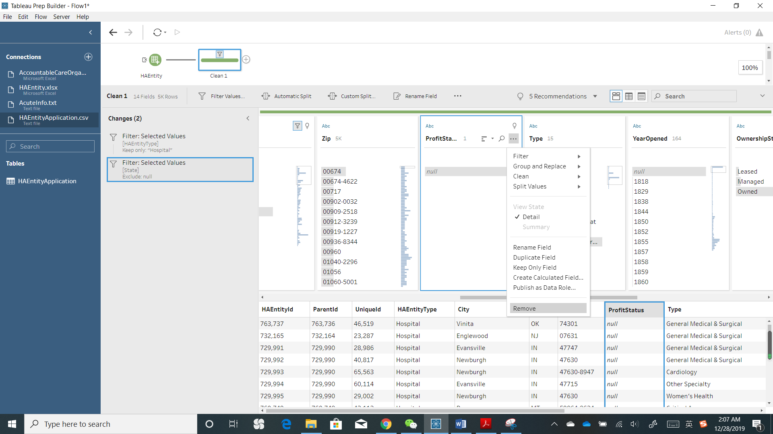
  - We keep looking at each variable. YearOpened has null values, 350 (6%) rows. It is a moderate level, hard to say delete it or replace it with other values. I’ll keep it in mind but leave it for now. VendorSelStrategy column has only 2 rows that are not null (i.e., mitigating to a single vendor approach) – this is quite disappointed, because I wanted to see how hospitals’ vendor selection strategy could affect their performance. But the data doesn’t allow me to do so, at least in this dataset. So, we remove the column. FTETotal has 72% null value, so I just leave it for now.
  - Now, the data looks pretty clean, except for the two columns with missing values. But we still can make it better. First, we can remove the HAEntityType column, as this data is already only about hospitals. Second, we have City and State columns, which could be further specified the data role as Geo-type data. It will be useful later when we visualize data.
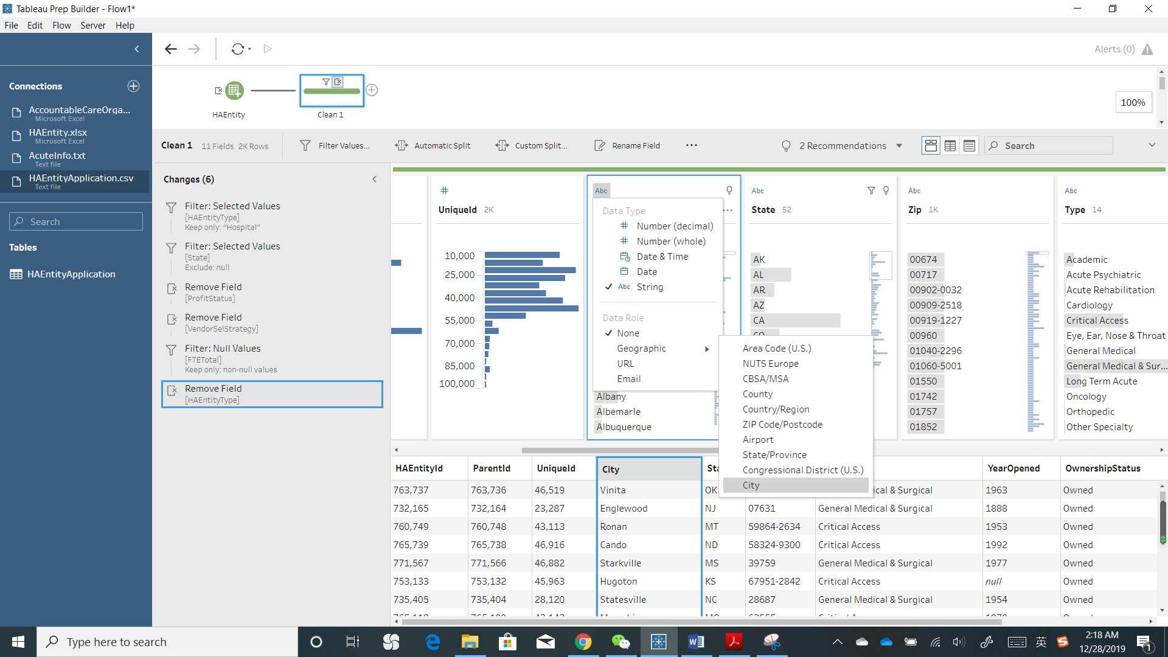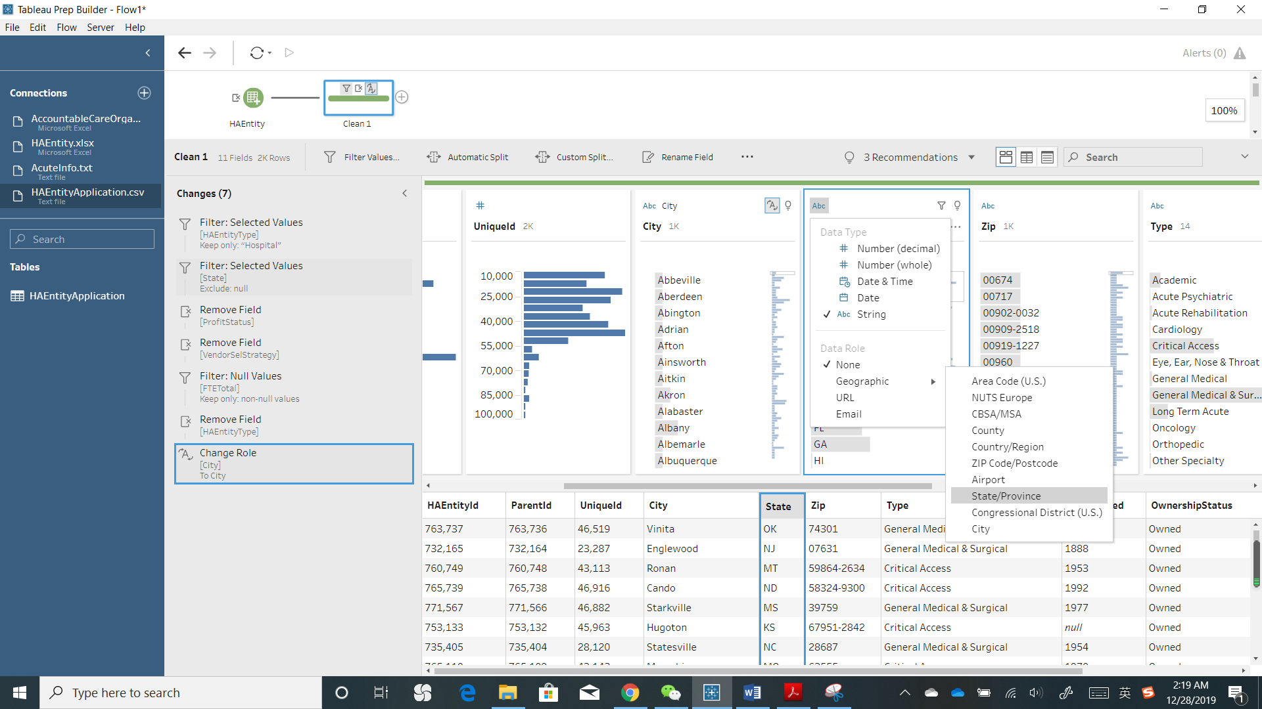
  - Let’s do a final check of data cleanness. Opps, Tableau Prep Builder has 2 recommendations. Let’s what they are. Both are about the City column. The St. Albans versus St Albans. There should be no dot. So we apply the Group and Replace recommendation.
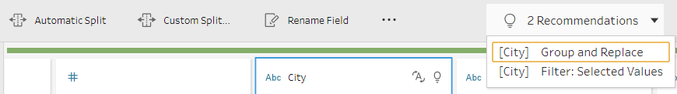
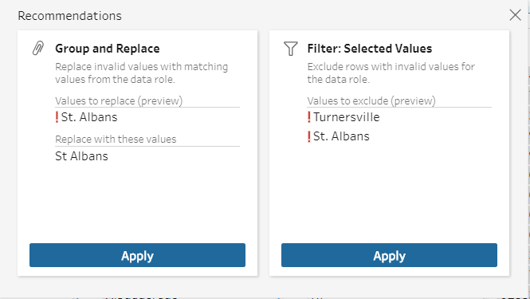
  - Ok. Done with this step. All data looks clean. We can rename this step as Clean HAEntity (right click on the step).
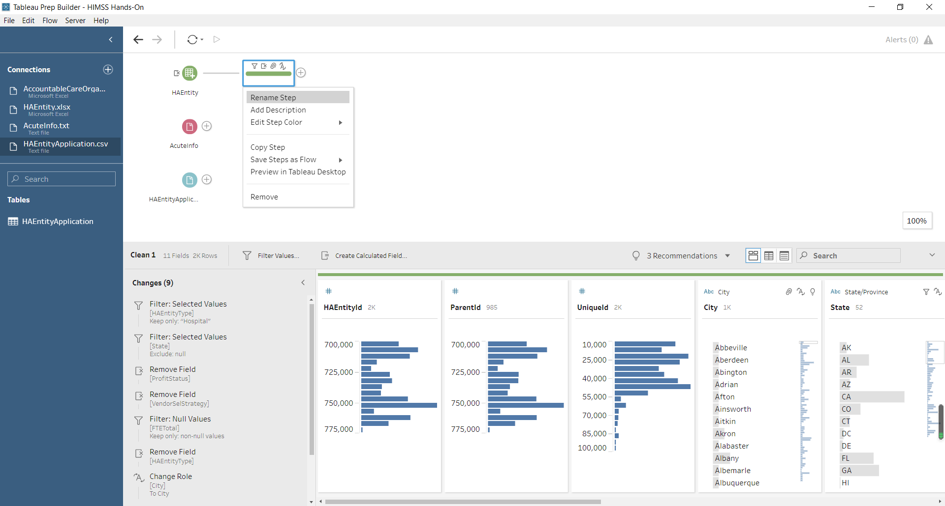
- Transforming Data
  - Based on my research needs, I should compute some variables based on the existing data. Add a Clean step after the step of Clean HAEntity. Rename the step as Data Transformation.
  - Looking at the column Type. Based on my reading of literature, previous research cares about whether a hospital is academic or not and has theoretical reasons for it. So, I need a binary variable. Create a calculated field. (Note: here we use Tableau If-Else function) 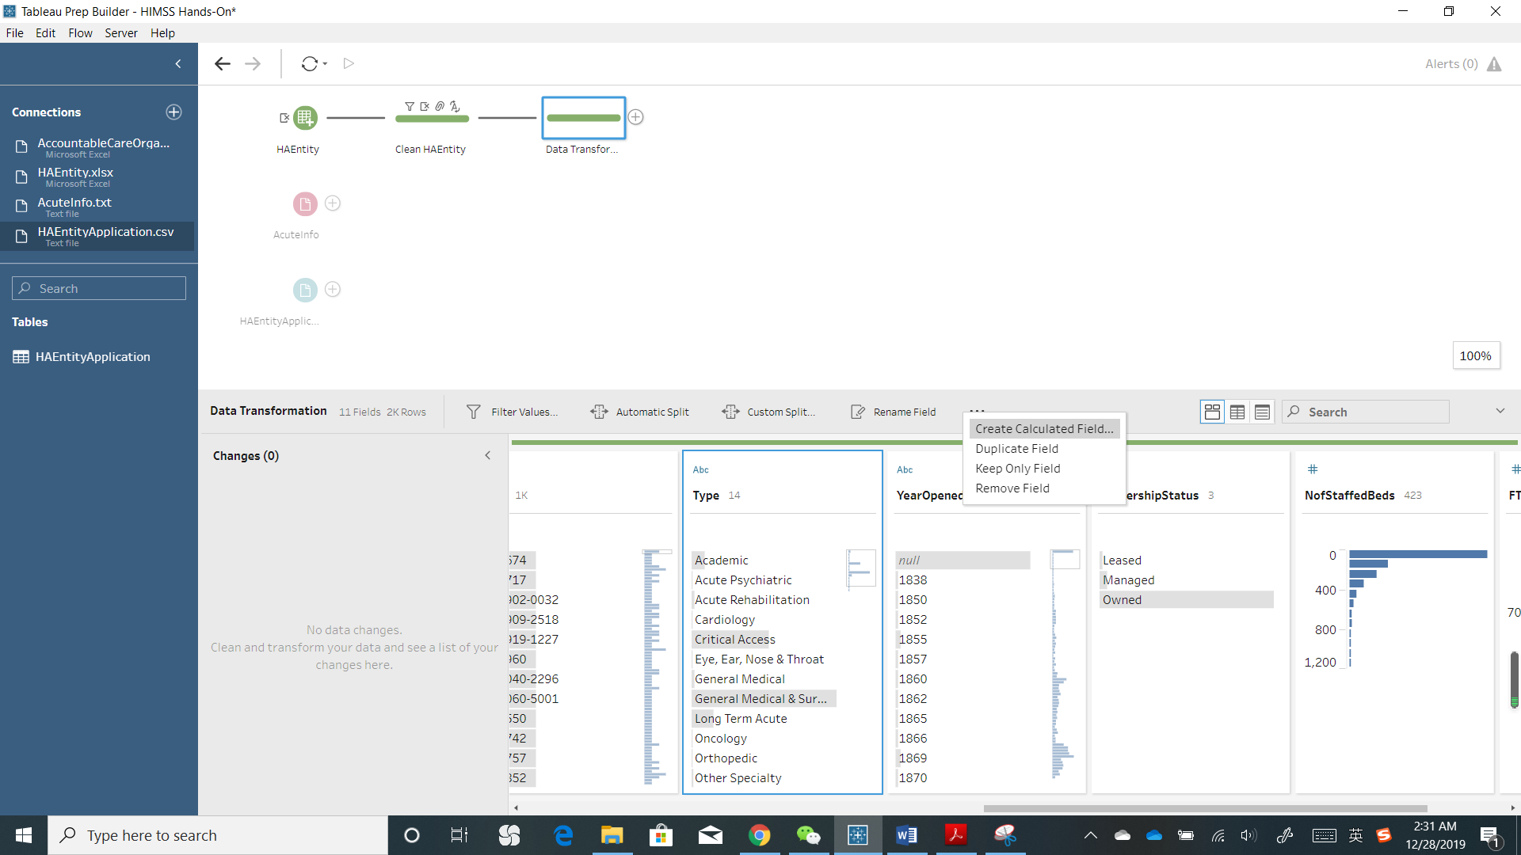
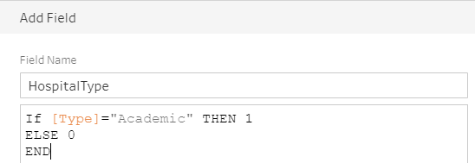
Here, we also can use the Group and Replace function. Go to More Options Group and Replace Manual Selection. Click on Academic on the left pane, then double click and change the value to 1. Use the same method to group all other values, and change the grouped value to 0.
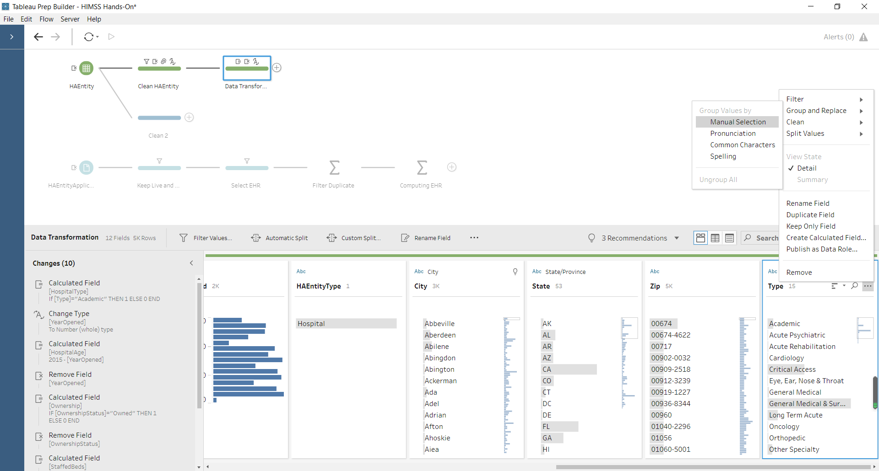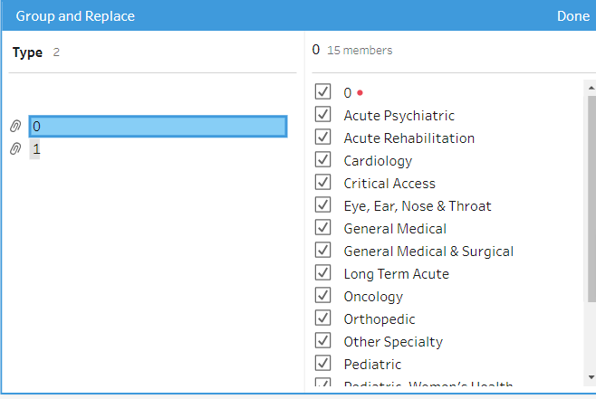
Ok. Both methods work the same. We just keep one and remove the column Type.
  - Next, instead of YearOpened column, we need to use hospitals’ age as a variable. So, we create a new column named HospitalAge, and use 2015 minus YearOpened. Error! Read the message, integer and string. Oh, YearOpened is a string type. How to fix it? Go back to change the data type. Then use the same function. Remove the original variable YearOpened.
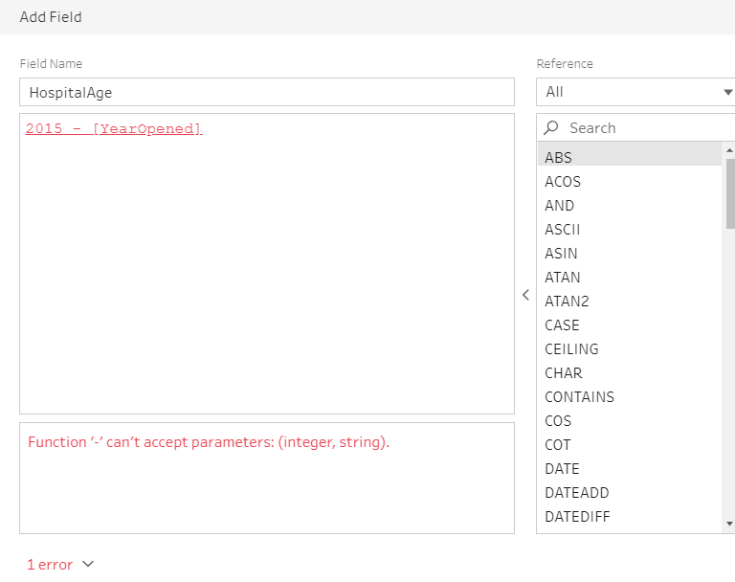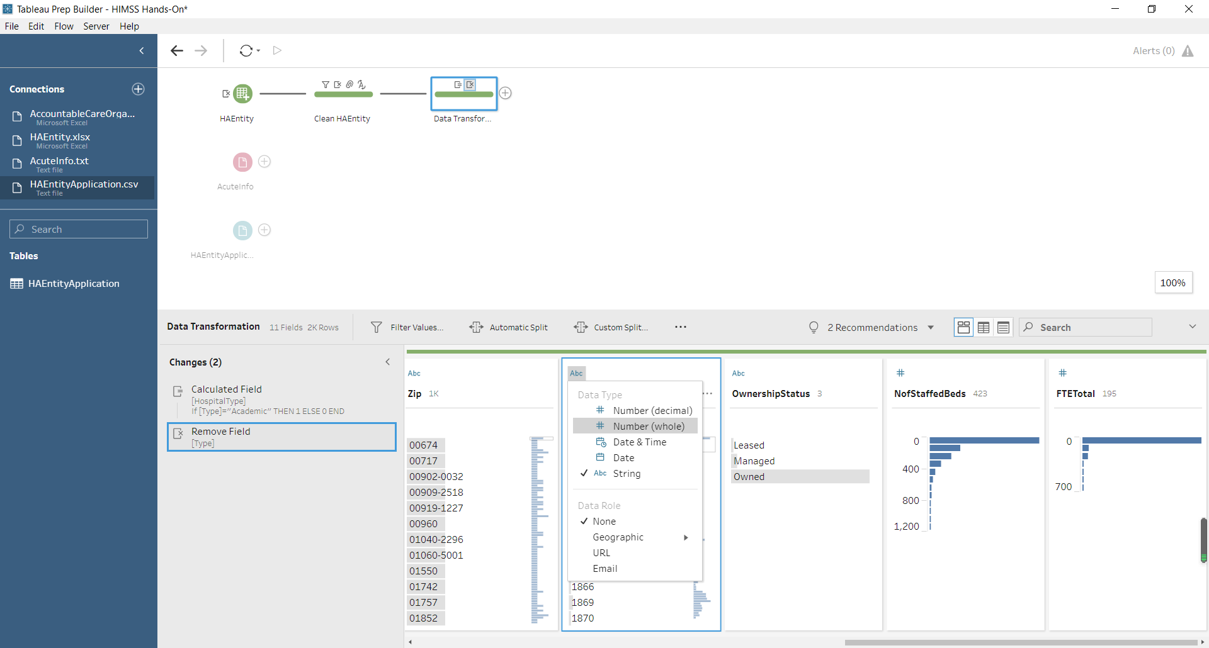
  - Similarly, can you create a binary variable based on OwnershipStatus, such that if the hospital is owned, the value is 1, and otherwise 0? Name the new column as Ownership. After that, remove the original column.
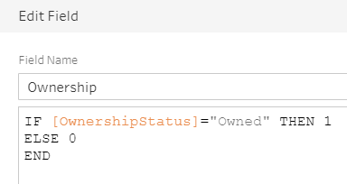
  - Then, we also examine the distribution of continuous variables. Here, we see the histogram of NofStaffedBed and FTETotal, indicating that both variables are not normally distributed. Usually, in an analytics project, we can do a logarithm to make it better. We create a new variable StaffedBeds, equals to log(1+NofStaffedBeds). FTE = log(1+FTETotal). We use 1+… to avoid taking log on zero.
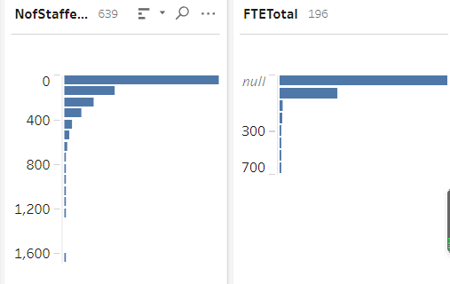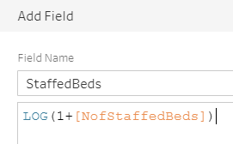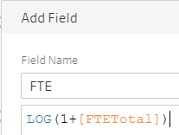
- Aggregating and Joining Data
  - In the healthcare sector, we know that health system is an important business model, where several healthcare organizations affiliate to the same health system. In academic research, previous studies have calculated and used the size of health system—i.e., total number of health organizations in the same system.
  - In our data, we have HAEntityId and ParentId. We need to calculate the number of HAEntity for each ParentId. To do this, add a step of Aggregate after HAEntity. Use ParentId as the Grouped Fields and Number of Rows (Aggregated) as Aggregated Fields. Rename the step as Computing Health System Size.
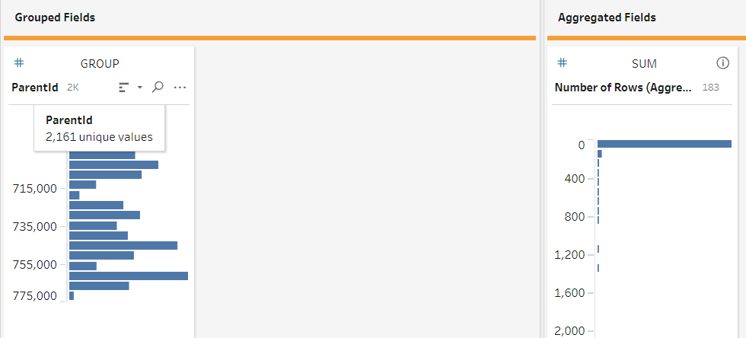
  - Now, we have this health system size for each ParentId. We need to match to each HAEntity. Add a Join step. To do this, we can drag the Computing Health System Size step to Data Transformation step and move to the Join option.
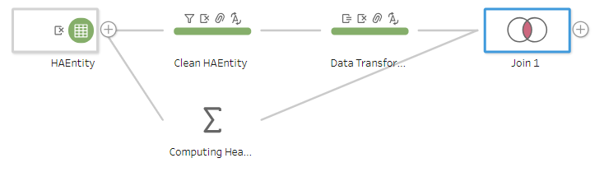
  - Use ParentId as joining criteria and specify them in Applied Join Clauses. For join type, not that here the Data Transformation table includes all hospitals that we want to keep. So, we should specify Left Join as the Join Type. Rename the step as Add Health System Size.
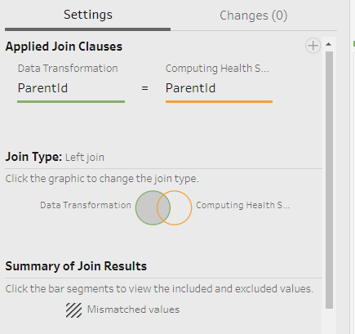
HAEntityApplications Table
- import HAEntityApplications.csv
  - keep the data fields HAEntityId, Application, and Status
- Examining and Cleaning HAEntityApplications Data
  - Add a clean step
  - This table records each healthcare organization’s IT applications at different stages. From this table, we count the number of certain types of applications. We only keep the applications that are live and operational. To do this, select more options Filter Selected Values check the box of Live and Operational (make sure use Keep Only on the top). Rename the step as Keep Live and Operational Apps.
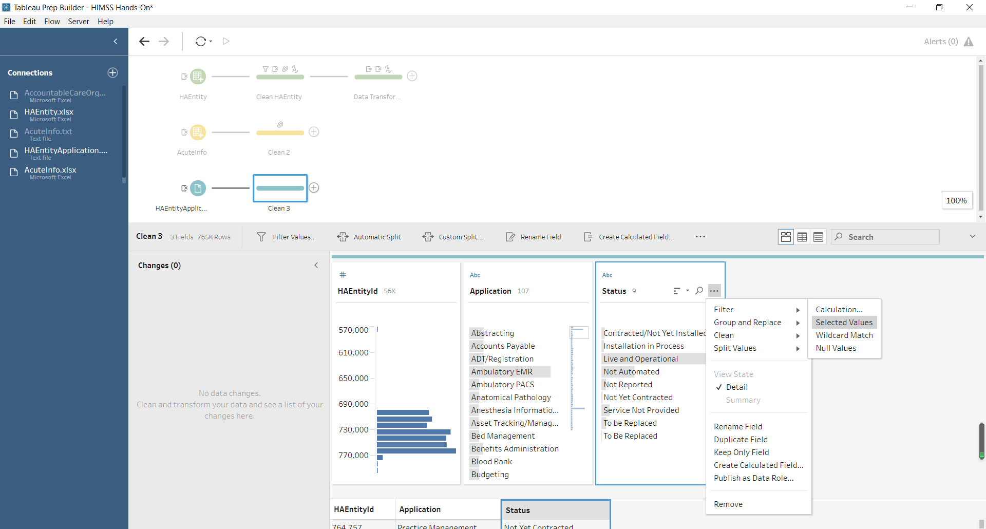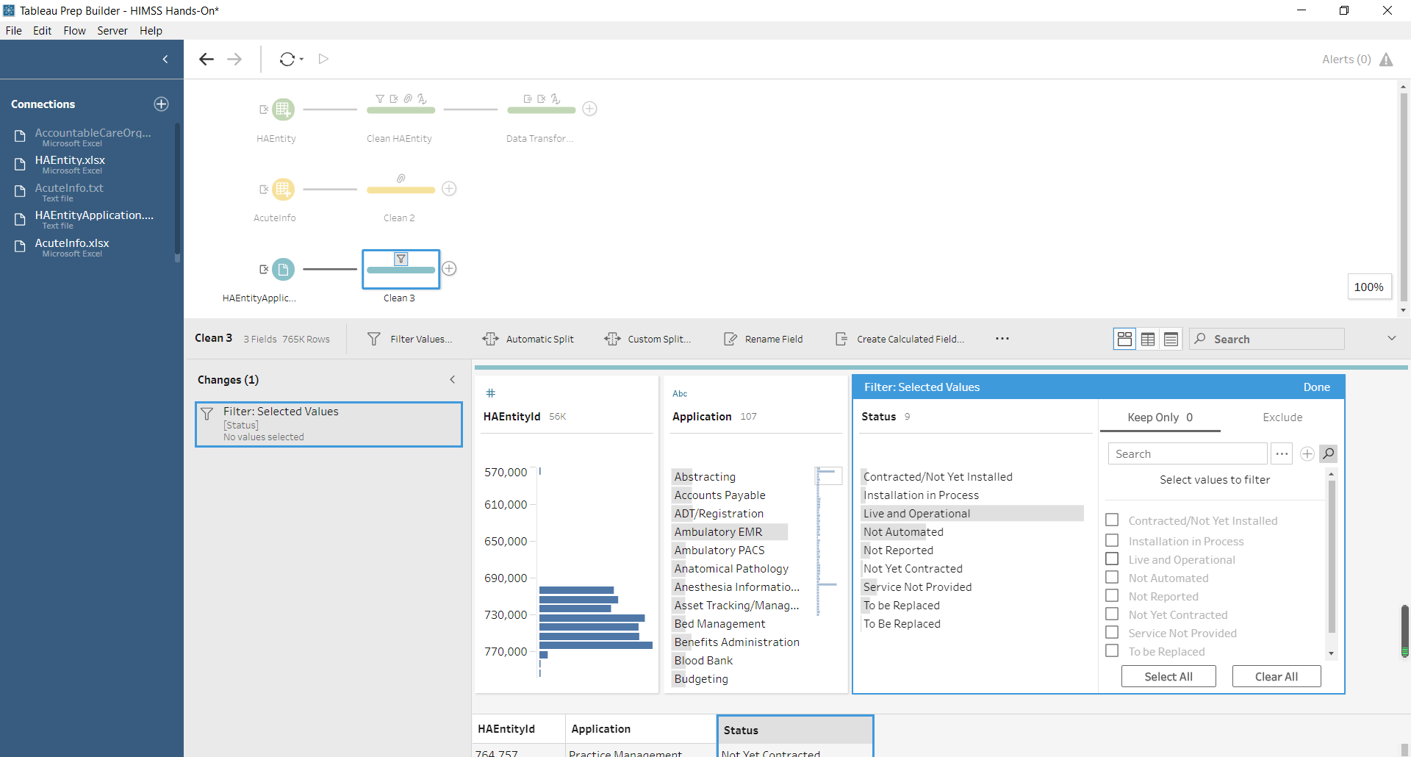
- Data Aggregation
  - We also need to compute a new column—each health organization’s total number of EHR applications. Based on literature, we use five EHR applications, including Clinical Data Repository, Clinical Decision Support Systems, Computerized Practitioner Order Entry, Order Entry, and Physician Documentation.
  - Add a Clean step, use a filter to keep these five categories only; Rename the step as Select EHR.
  - Add a step of Aggregate. Drag HAEntityId to Grouped Fields, Drag Number of Rows (Aggregated) to the Aggregated Fields. However, did you notice the problem of this? We only have 5 type of applications, but here the aggregated range from 1 to 12.
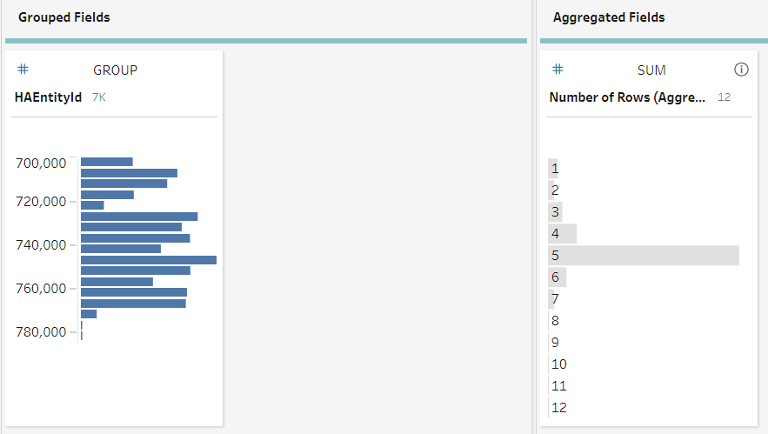
  - The problem is that a hospital may have one type of EHR in different functional areas. But we don’t want to consider this as different EHR. To do this, we use two-step aggregate function. First, put both HAEntityId and Application in the Grouped Fields. Rename the Step as Filter Duplicate. Then, add a new Aggregate step after Filter Duplicate. Choose HAEntityId as the Grouped Fields and Number of Rows (Aggregated)-1 as the Aggregated Fields. Rename the Step as Computing EHR.
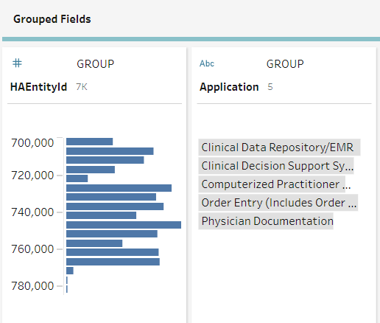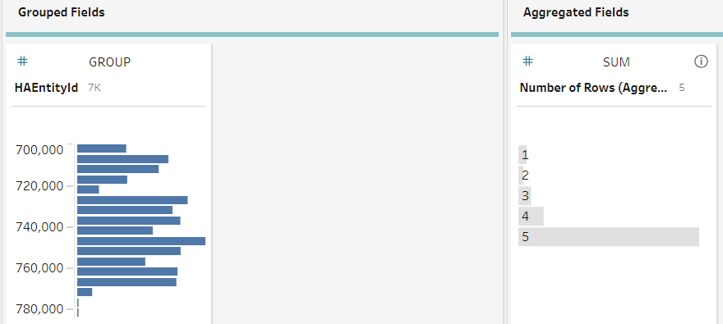

Consolidating Data
- Now we have all variables ready, but they are in separate files. We can consolidate them into one table.
- Add a Join step. To do this, we can drag the Computing EHR step to Add Health System Size step and move to the Join option.
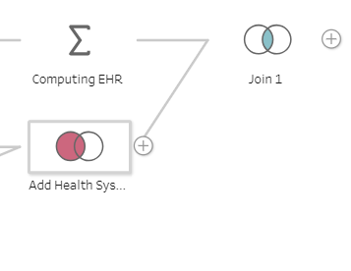
- Use HAEntityId as joining criteria and specify them in Applied Join Clauses. For join type, not that here the Add Health System Size table includes all hospitals that we want to keep. So, we should specify Left Join as the Join Type. Rename the step as Health IT Combined Data.
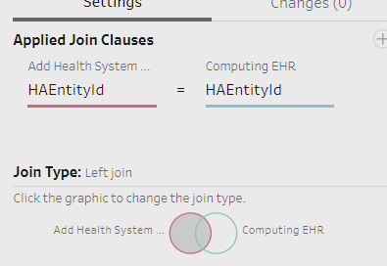
- After joining all tables together, there will be some null values for mismatches. Let’s do a final data cleaning. Add a Clean step and examine the final data. The column Number of Rows (Aggregated) – 1 is the computed column for number of EHRs. Rename it as NofEHR. This column also has null value, which means a hospital doesn’t have any EHR system in use. So, we can replace this null value with 0. We can do right-click, and choose edit value.
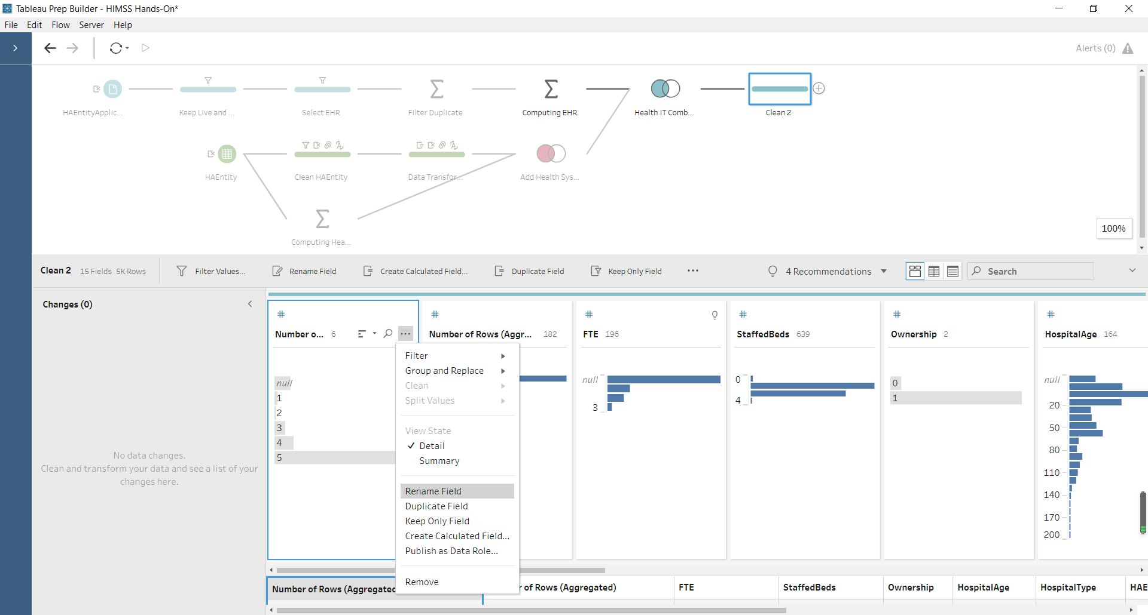
- Number of Rows (Aggregated) is the column of health system size, which we just computed. Also, this variable is not normally distributed. We can use logarithm to transform it and rename it as HealthSystemSize. Then remove the original data column.
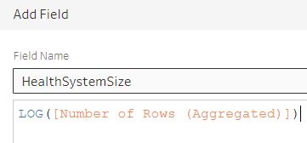
- HAEntityId-1 is same with HAEntity. So, we just remove the HAEntity-1. Same thing, we remove ParentId-1.
- Now, look at the data. It has all variables I need in one file, and are properly cleaned and transformed. Rename this last step as Health IT Final Data. We can preview this final dataset in Tableau Desktop (right-click). Then, you will be able to move to the next step of Data Visualization using Tableau Desktop, which will be covered in our next topic.
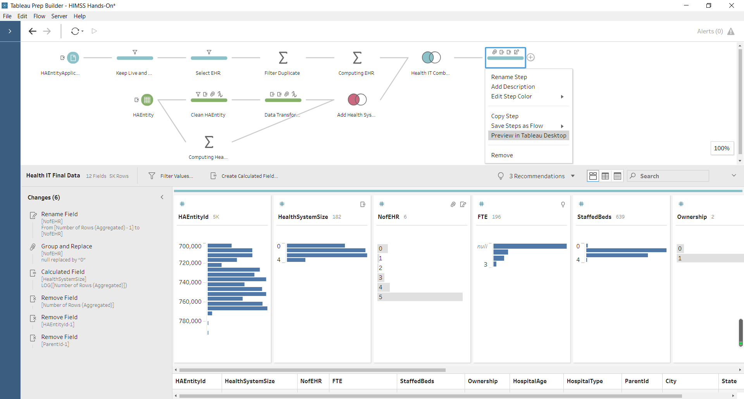
- Finally, you can export the data as a Tableau Data Extract. It will be used to import to Tableau when you do visualization. Add a step of Output. Click on Browser to specify the designated folder. Same the file as Output_HealthIT.

Final Flow
The final Tableau Prep flow is given as follows. In this example, we have gone through all major processes of data manipulation and integration. In your project, you will do similar things. You will have some problems at different steps. Think of the data that you need and how you will prepare the data for your analysis.
